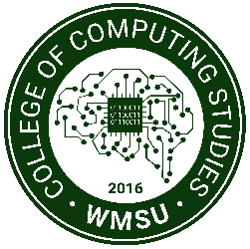Republic of the Philippines

Western Mindanao State University

**COLLEGE OF COMPUTING STUDIES**

DEPARTMENT OF INFORMATION TECHNOLOGY

**“LearnHear: An English E-learning Application for Visually Impaired Pupils Using Natural Language Processing”**

A CAPSTONE PROJECT

Presented to the Faculty of the

College of Computing Studies

Western Mindanao State University

In Partial Fulfillment

of the Requirements for the Degree

Bachelor of Science in Information Technology

By

MEMBERS

ASAKIL, SARHAN

CAFINO, ANDREI

ISMULA, MOHAMMAD IYANG G.

MR. JOHN ESCORIAL

Faculty Adviser

July 14, 2023

# CHAPTER 1

**INTRODUCTION**

**1.1** **Project Context**

The incorporation of technology into learning environments has contributed significantly to recent breakthroughs in the field of education. However, accessing educational resources presents particular difficulties for visually impaired pupils, particularly in disciplines like acquiring an additional language. The LearnHear project intends to create a cutting-edge English e-learning program exclusively for pupils who are visually impaired in order to address this problem. This application will enable these pupils to improve their English language abilities in a more inclusive and accessible way by utilizing a subset of artificial intelligence (AI), known as natural language processing (NLP), dealing with how computers and human language interact. In order to process, comprehend, and produce data in natural language, computational algorithms and procedures must be developed and put into action.

The incorporation of Natural Language Processing (NLP) in LearnHear, an English e-learning program for visually impaired pupils, has enormous potential to improve language learning outcomes. Pupils who are blind or visually handicapped can use speech recognition and text-to-speech technologies to communicate with the system since NLP enables the program to comprehend and process human language. LearnHear can accurately record students' spoken responses, evaluate their pronunciation, and give fast feedback by utilizing NLP techniques. This helps to advance accurate language learning and oral proficiency.

Moreover, NLP enables LearnHear to provide each learner with a customized learning experience. Through the use of adaptive learning strategies, the program may assess user performance, pinpoint strengths and weaknesses. This individualized method guarantees that visually impaired elementary students get specialized support, practice activities, and challenges that are compatible with their skills, enhancing learning results and encouraging engagement.

**1.2** **Purpose and Description**

The main objective of the proposed “LearnHear: A English E-learning Application for Visually Impaired Pupils Using Natural Language Processing” is to provide an English e-learning program that is tailored exclusively to the requirements of visually impaired pupils. This application intends to give these students an inclusive and accessible platform to improve their English language proficiency by utilizing speech recognition and text-to-speech technology. The ultimate objective is to empower visually pupils, encourage their independence in learning environments, and advance equal educational opportunities.

In line with elementary school requirements, LearnHear provides a thorough English language education. Vocabulary, grammar, intonation, and spelling are the English language learning topics covered in the program. The application has interactive learning activities like vocabulary tests, grammar drills, intonation drills, spelling and listening comprehension exercises that make learning interesting and customized for the needs visually impaired pupils.

Pupils can learn at their own pace and receive specialized guidance in areas where they need more practice. The pupil's successes and growth can be tracked using progress tracking features, which gives parents, teachers, and pupils important information for additional support and intervention.

**1.3** **Project Objectives**

This section presents the general objective and the specific objectives of the study.

**a.** **General Objective**

* The general objective of LearnHear e-learning application is to provide visually impaired pupils an inclusive and effective platform for them to learn and improve their English language abilities. The application utilizes NLP approaches to enhance accessibility, interaction, and individualized learning experiences for visually impaired pupils, empowering them to communicate confidently and proficiently in English.

**b. Specific Objectives**

1. To design and develop a user-friendly English e-learning application tailored specifically for visually impaired pupils.
2. To implement accurate speech recognition utilizing NLP-based speech recognition algorithms to accurately transcribe spoken responses of visually impaired students. Providing the app the ability to evaluate pronunciation, offer immediate feedback, and provide suggestions for improvement, thereby enhancing their oral language skills.
3. To provide a comprehensive English language curriculum aligned with elementary school standards, covering vocabulary, grammar, spelling, and intonation.
4. To promote independence, and equal educational opportunities for visually impaired elementary students in the field of English language learning through the implementation of LearnHear.

**1.4** **Scope and Limitations**

LearnHear aims to provide visually impaired pupils the fundamentals of learning English as a second language. Lessons on vocabulary covering synonyms, antonyms, and context usage will be included. Lessons in grammar will emphasize important concepts like verb tenses and components of speech. Exercises using audio clips and dialogues will enhance pupils' listening abilities by letting them practice comprehension and ask and answer questions. Pupils' speaking practice will be supported by the use of speech recognition technologies. LearnHear makes sure that visually impaired primary pupils may acquire a comprehensive set of language skills that will enable them to communicate successfully and with confidence in English language.

The functionality of the application will be determined by the hardware capabilities of the devices used by visually impaired pupils, which may have an effect on performance. LearnHear focuses on English language learning and may not support other languages or cater to the needs of pupils learning languages other than English. Internet connectivity is necessary for accessing instructional materials and synchronizing progress, which may be limited or unreliable in certain contexts. The accuracy of pronunciation evaluation may be impacted by difficulties with speech recognition technologies in accurately recognizing accents, dialects, or speech patterns. The quality and breadth of the curriculum and features supplied by LearnHear may be impacted by resource constraints. For visually challenged pupils using the application, these restrictions should be taken into consideration to ensure reasonable expectations and a positive user experience.

**1.5** **Significance of the Study**

LearnHear: An English E-learning Application for Visually Impaired Pupils Using Natural Language Processing addresses a critical gap in inclusive education. LearnHear ensures that visually impaired pupils have equal access to educational resources and opportunities, creating inclusivity both inside and outside of the classroom by offering these pupils a platform for learning English that is accessible and inclusive through the use of a subset of artificial intelligence (AI), known as natural language processing (NLP).

The potential of the application supports the independence of visually impaired pupils. LearnHear promotes students' confidence, independence, and active participation in the learning process by having them communicate with the program using their voices. Visually impaired pupils can improve their pronunciation and speaking abilities as a result of the immediate feedback offered by speech recognition technology, which enables them to communicate in English more effectively and improve their overall proficiency in the language.

This study extends further to examine the broader impact it may have on the lives of visually impaired pupils. LearnHear gives pupils access to a larger range of educational and career prospects by providing them with essential English language skills. It ensures that the pupils may actively participate in a globalized environment by preparing them for higher education, and fulfilling social connections. It ultimately resides in its ability to change the educational environment for visually impaired students, encouraging inclusivity, independence, and equal access to quality English language instruction.

**1.6 Definition of Terms**

* **NLP-** Natural language processing (NLP) refers to the branch of computer science—and more specifically, the branch of artificial intelligence or AI—concerned with giving computers the ability to understand text and spoken words in much the same way human beings can.
* **E-learning Application-** eLearning apps provides you with access to engaging interactive content to keep you interested throughout the learning process. They provide a variety of elements, including tests, evaluations, videos, audio files, and others, to support learning in a variety of ways.
* **Visually Impaired-** Visual Impairment or Visually Impaired is a term used by experts to describe any degree of vision loss, including total blindness or someone who has partial vision loss.

**CHAPTER 2**

**REVIEW OF RELATED LITERATURE**

**2.1 Introduction**

This study focuses on the advantages of using the LearnHear mobile application, an E-Learning mobile application using natural language processing (NLP) design, with the intention of giving users a simple and intuitive way to navigate the application using the voice command option for elementary visually impaired pupils. Education is now more accessible than ever before in today's increasingly digital society. However, significant difficulties remain, notably for visually handicapped children. Learning English can be a difficult task for primary pupils with visual impairments, requiring particular resources and methods to assure their success. This is where LearnHear comes in: an English e-learning app built exclusively for visually impaired primary children, utilizing the power of Natural Language Processing (NLP). Overall, this mobile application can be a valuable tool for visually impaired primary children to help them learn about English topics.

**2.2 Summary**

Visual impairment (blindness, low vision, and color blindness) is a type of impairment. contains everything from low vision for students who are partially sighted and can read print in general to total blindness for those who are blind and unable to read print. Depending on their specific circumstances, students with visual impairment "may not be able to rely on the sense of sight to obtain information, observe their surroundings, and learn about the world" (Presley and D’ Andrea 2008). The consequences of being unable to use all of one's visual capabilities can have a detrimental influence on areas of students' lives and learning with impaired vision.

Nowadays, E-learning is growing more popular. significant instrument in the learning process of visually impaired children (Kharade and Peese, 2012) and has the potential to facilitate these pupils' inclusion (Fichten and colleagues, 2009).

Peese and Kharade define e-learning as the provision of learning, training, or education through an electronic program spanning a wide range of web-based apps and procedures. For example, learning, computer-based learning, virtual classrooms, and digital collaboration are all examples of digital collaboration. (2012,)

The same writers believe that e-learning is beneficial. Encourage remote learning for students with visual impairments, encourage teachers to provide remote assistance to students with disabilities, support these pupils, and promote ongoing education for visually impaired students. Thus, e-learning results in "more effective and efficient learning strategies for gathering and disseminating knowledge beyond the confines of regular educational settings" (Buzzi et al. 2012).

Learners with vision impairments must adjust and use e-learning, which is one of the most popular tools used by teachers in postsecondary education to help with the learning process (Fichten and colleagues, 2009). E-learning allows students with visual impairments to be included in courses, making it easier for them to access class materials. (Fichten and colleagues, 2009). Fichten and colleagues (2009), however, observed a decrease in the use of e-learning for visual learners by teachers in colleges and universities and a lack of experience with it.

Educational materials designed for sighted students are frequently inappropriate for sighted students. As a result, individuals with impairments encounter unique problems at an early age. because of the unsuccessful support for assistive technology and learning difficulties with material accessibility (Fichten and colleagues, 2009; Hollier and Permvattana, 2013). Educational Materials should be made available in a variety of ways, including visually, audibly, and tactilely (Buzzi and colleagues, 22012), making them available to all people with disabilities.

In the education field, based on each individual student's needs for cognitive computing services and artificial intelligence (AI) powered by data to enhance knowledge in an effective and individualized manner, content, planning, and intelligent activities are used. In fact, according to Coccoli, Maresca, and Stanganelli (2016), "from the standpoint of e-learning, cognitive computing can act as a catalyst for kids' accomplishments and a great resource for teachers" (2016,

The demand for mobile apps is rising, creating experiences that are accessible to blind smartphone users with disabilities. Microsoft has released, on July 17, the new free artificial intelligence application for Apple’s iPhone, called Seeing AI (formally known as Deep Vision), designed for the low-vision community. This app uses a mobile camera to describe people; text, currency, color, and items being photographed are all examples of this. This app has the ability to transform the visual environment into an audio experience (Microsoft n.d.), which is used in educational settings to overcome the visual barriers faced by these learners.

Artificial intelligence has the potential to make education a more effective and interesting experience, both for students and teachers, as well as "the current lack of "sophisticated application of AI technologies in education. The distinction between colleges and universities can be explained by a scarcity of financial resources as well as a scarcity of data demonstrating the efficacy of the technologies" (Stone and colleagues, 2016).

Virtual assistants, sometimes called intelligent assistants, from Amazon, Apple, Google, and Microsoft—Alexa, Siri, Google Assistant, and Cortana are a few examples. respectively, are voice command platforms capable of carrying out a variety of tasks. As a result, using these platforms, students can connect with them at school and learn from them. personal feedback in real-time. As an example, consider the following: Visual learners can benefit from platforms. impediment in locating library materials more quickly.

Because the rise of digital voice assistants in education is unavoidable, it is critical that educational systems investigate how they might build more of them. Learning in an effective, entertaining, and innovative environment. "Teachers must develop new skills for visually impaired students in mainstream schools," in contrast to these "from the traditional training model dating from the special school and sight class era" (Söderberg and Fellenius 2000).

**CHAPTER 3**

**TECHNICAL BACKGROUND**

The technicalities utilized to create the system are discussed in this chapter. It covers the conceptual framework, the programming environment, and the hardware requirements used during both the development and implementation phases of the application.

**3.1 Conceptual Framework**

This section presents the conceptual framework of this study and the ideas that needed to be achieved at the end of the study.

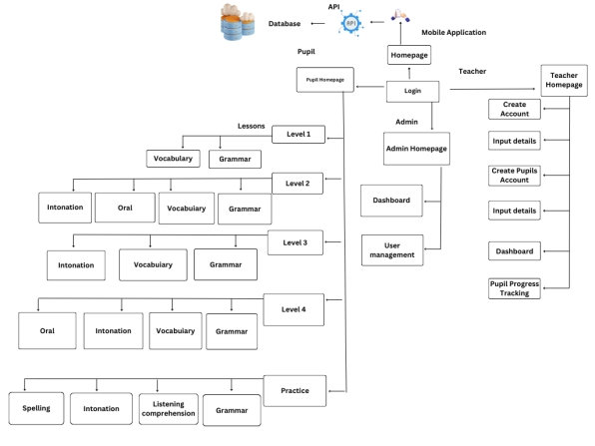

*Figure 3.1 Conceptual Framework of the LearnHear application (an e-learning app for visually impaired students)*

The concept and function of the system are shown in the above figure. The administrator has full access to the system and can log in using the login button. Teachers on the other hand have limited access to the system, and can only perform certain actions, such as creating an account, entering data, creating an account for pupils and tracking progress. While the pupils can login with the help of a guardian or a teacher. When a teacher creates an account, the app will ask for the information about the teacher’s name, email, school and number of pupils. Overall, the system is designed to provide a user-friendly and intuitive interface for visually impaired students to learn English effectively and enjoy at the same time.

The administrator has full access to the system and has the authority to perform a range of tasks, including adding new administrators, altering user details, modifying, monitoring, and removing users, and adding lessons. In addition to these tasks, the administrator can also access user data, view pupil’s progress and perform other functions as needed to manage the system and support users. Overall, the administrator has a crucial role in ensuring the smooth and efficient operation of the mobile app, and in providing the necessary support and guidance to users to help them learn and help them get promoted to graded level.

The mobile app will need to connect to an API, which means that it requires an internet connection to operate. Connecting to an API (application programming interface) provides a number of benefits, including scalability, flexibility, and security, which can help support the efficient and effective operation of the mobile app. Additionally, LearnHear uses a database to store user and administrator data. This database is a crucial component of the system, as it enables users to enter and update their data, and allows administrators to access and manage this information. The database is designed to be secure and reliable and can support the efficient storage and retrieval of large amounts of data. Overall, API and database are important components of the mobile app, and help to ensure that it is reliable, efficient, and effective in supporting pupils in learning basic English.

**3.2 System Features and Components**

1. ***Login –*** This module allows the Admin, Pupil or Teacher to log in their specific Accounts. The following are the sub-modules of the system:

* 1. ***Admin Login Form*** – This sub-module allows the **Admin** to input the Username and Password.
  2. ***User Login Form*** - This sub-module allows the **User** to input the Username and Password.
  3. ***Log-in/log-out*** – This sub-module allows admin or user to log-in and log-out their specific Accounts.

1. ***Dashboard –*** This module displays the **total number of users, progress of pupils**.
   1. ***Display total number of users*** – This sub-module allows the Admin to know the total number of the user registered in the system.
   2. ***Pupils progress tracking*** – This sub-module allows the Admin to know the progress of pupils in learning English.

1. ***User Management –*** This module allows the admin to manage user account by approving new user’s account creation request, delete and create another admin. The following are the sub-modules of the system:

3.1 ***Delete User Accounts* –** This sub-module allows the admin to delete the user accounts in the system.

3.2 ***Create or Add another Admin*** - This sub- module allows the admin to add another admin.

3.3 ***View or Track User’s Information*** - This sub- module allows the admin to view information of the user in the system.

**3.2 Software Requirements**

The following is the list of software requirements used for development and implementation of the system.

**3.2.a Programming IDE (Integrated Development Environment)**

* **Visual Studio Code -** is a ***code editor*** redefined and optimized for building and debugging modern web and cloud applications.

**3.2.b Programming Language**

* **Flutter** is a versatile open-source framework developed by Google for creating high-performance, cross-platform mobile, web, and desktop applications using a single codebase and will be used in developing the ***front end.***
* **Django** is a powerful and popular open-source web framework written in Python that simplifies the development of robust, scalable, and secure web applications.

**3.3 Hardware Requirements**

The following is the list of hardware requirements that are needed by the user to be able to use the application and hardware requirements for the development phase.

**Hardware used by the developer for the development phase:**

Android API level: API level 30 & above (Android 10)

Memory/RAM: 4gb & Above

**CHAPTER 4**

**DESIGN AND METHODOLOGY**

This chapter presents the design process and methodology of the development of the project.

**4.1 Introduction**

An efficient and adaptable project management methodology is needed for the development of LearnHear, an English e-learning application for pupils who are visually impaired using Natural Language Processing (NLP). Given the specific needs and constraints of LearnHear, the agile methodology is an appropriate framework for its development. The Agile model is a flexible and iterative project management methodology that emphasizes collaboration, adaptation, and continuous improvement. It is best suited for projects with complex requirements, changing demands, and a high degree of involvement from stakeholders. For the application LearnHear, which is intended for visually impaired pupils, it was important to integrate modern NLP technology, taking into consideration accessibility concerns, and follow educational guidelines.

The Agile model offers numerous advantages that align closely with the specific demands of developing LearnHear. Iterations and regular feedback are made feasible by the Agile methodology, which is essential for an application like LearnHear. Since pupils who are visually impaired have a variety of learning demands, it is crucial to continuously gather feedback and insights from teachers, parents, and the actual pupils themselves throughout the development process. Agile's iterative nature and its short development cycle, known as sprints, allow the development team to absorb input and make the necessary adjustments to enhance the usability and efficiency of the program.

**Design** - This section has to be effective at putting the design into practice, and the group members need to work closely with the advisor and the provided storyboard so that the UX and UI can be carefully checked from time to time and evaluated to determine what works best for the systems design and user experience.

**Plan-** During this stage, the researchers developed a strategy for how the team will collect the data needed to build the system, including how the system will apply the aspects of the data it needs to function.

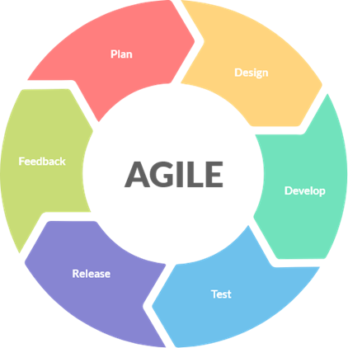

**Feedback-** The feedback phase will be used if the target users have any comments about the application or how it may have benefited the users when they used the application.

**Development** - The LearnHear application's functionality and features will be implemented by the developers, who will concentrate on building the system.

**Release and Test Phase-** The release and test of the system or application is for the chosen target users who are visually impaired students.

**4.2 Requirement Analysis**

The development team does an analysis to determine what are the key requirements and features of the application after acquiring the necessary information. This analysis aids the team in comprehending the requirements and expectations of users and identifying the functionalities and features that are most useful and significant to them. Based on this analysis, the team prepares a proposal that explains the project's scope, objectives, and anticipated results. It then submits this proposal to the panel for assessment and feedback. LearnHear should include NLP-based features to improve the learning experience. These include speech recognition for voice interaction, text-to-speech technology for turning text into speech, and natural language processing for deciphering and responding to user input. Advanced language modeling should be used to provide precise recommendations and corrections during language activities, and pronunciation assistance through audio feedback to help visually impaired pupils become more fluent in English.

The content and curriculum of LearnHear must align with the English language curriculum for visually impaired pupils. To accommodate different learning preferences, multimodal learning resources that include text, audio, and interactive components should be provided. The program should monitor pupils' advancement, enabling them to keep track of their accomplishments and receive personalized recommendations. The interactivity and user interface of LearnHear are essential to its usability and accessibility. pupils who are blind or visually impaired may use the program with ease because of its clear and straightforward design and auditory signals and feedback. The use of voice commands and graphical displays makes communication more effective.

**4.2 Flowchart**

The Flowchart diagram below shows all the features of the system process throughout the flow of the diagram using the LearnHear : An English E-learning Application for Visually Impaired Pupils Using Natural Language Processing.

**Create Account for Teacher**

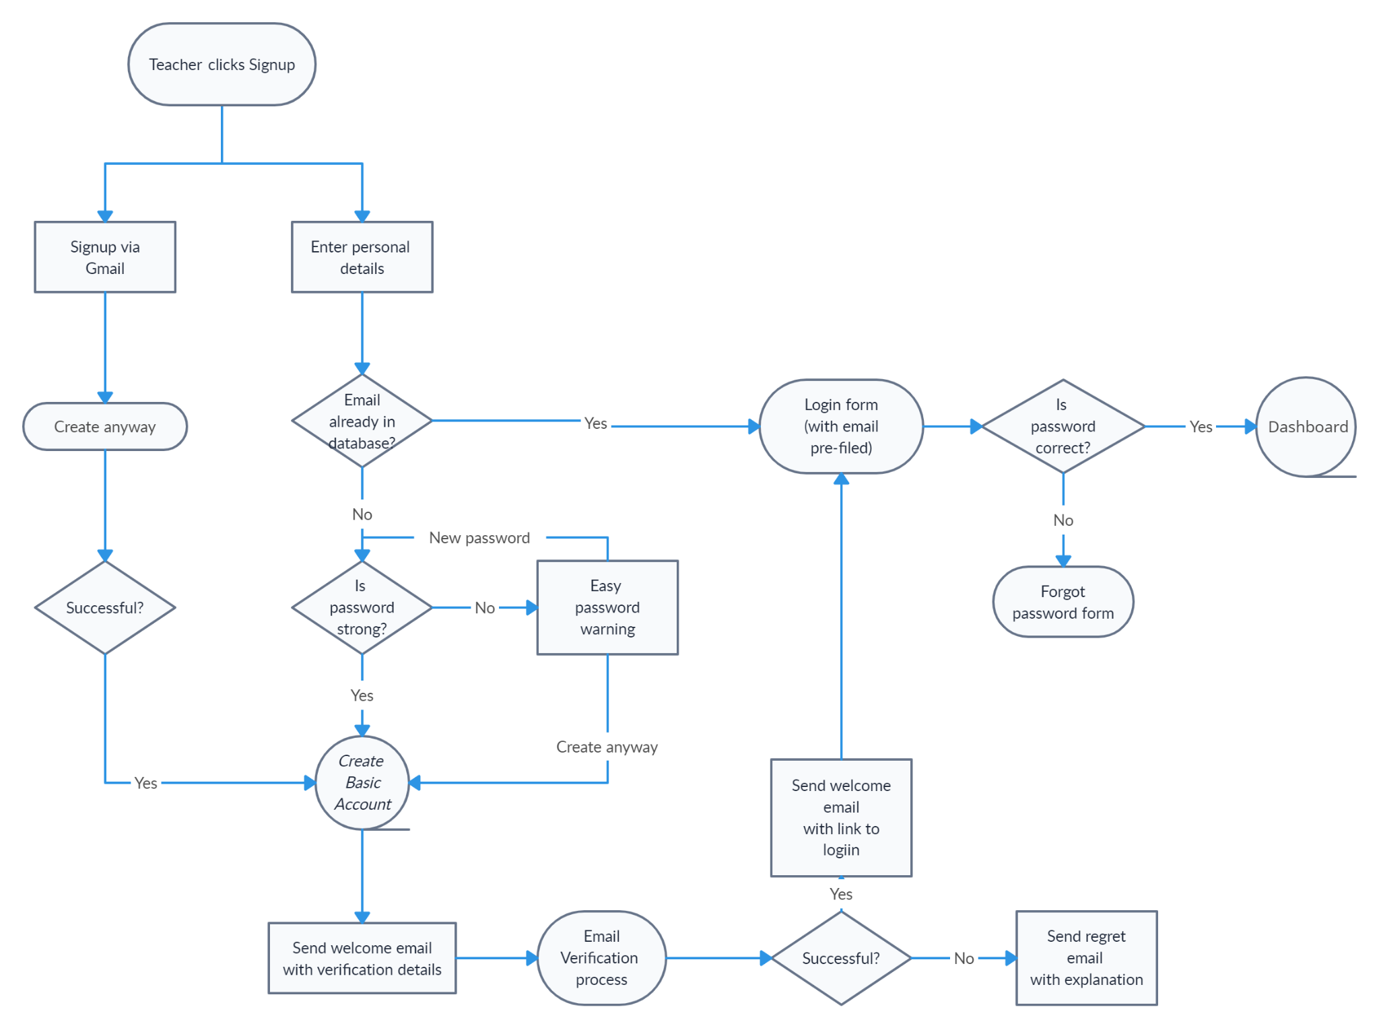

***Figure 4.2 Flowchart of the Create Account for Teacher feature of LearnHear***

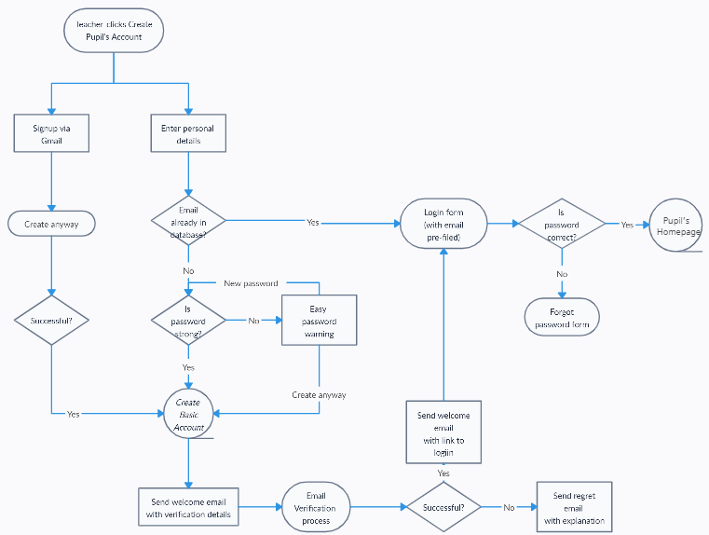**Create Account for Student**

***Figure 4.2 Flowchart of the Create Account for Student feature of***  ***LearnHear: An English E-learning Application for Visually Impaired pupils Using Natural Language Processing.***

**4.3 Use Case Diagram**

The use case diagram illustrates the various ways in which a user and a system could interact. The user is represented by the icon labeled "User," and the system or application is represented by the rectangle labeled "LearnHear: An English E-learning Application for Visually Impaired pupils Using Natural Language Processing." The arrows between the user and the system represent the different interactions that a user or student can do. For instance, the user can use the voice command in order to choose which level that the user wants to access, and what kind of topic the user wants to learn. The use of case diagrams also demonstrates that the instructor has other powers, including the power to add or delete pupils, accept or deny the user accounts, and track the progress of a student.

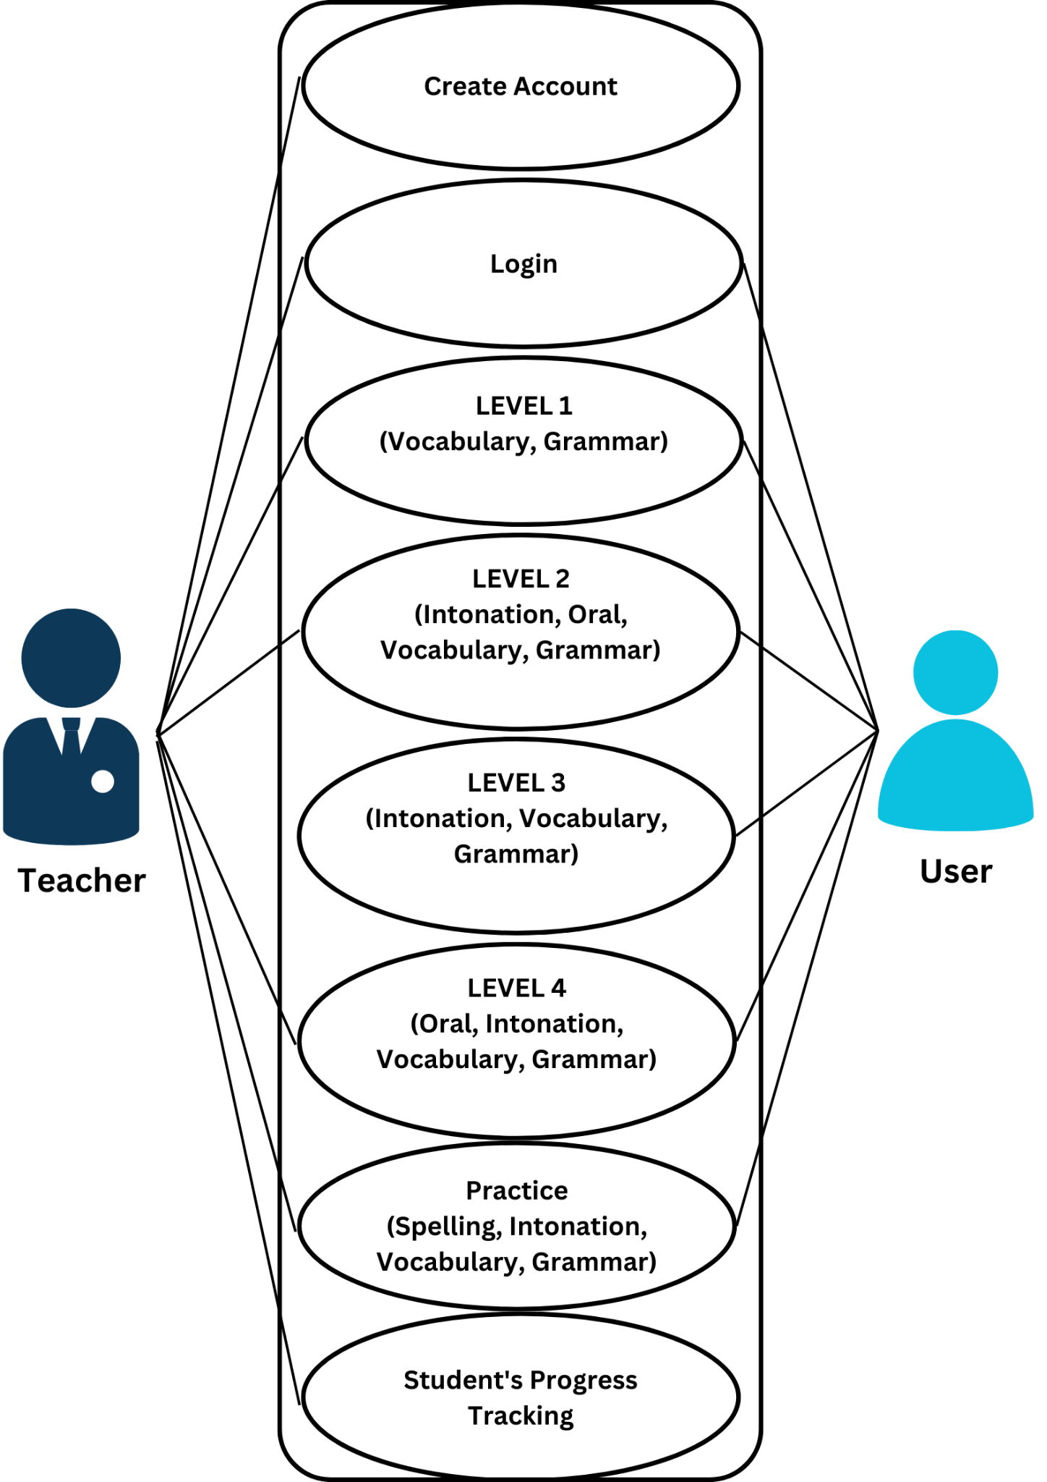

***4.3 Use Case Diagram of*  LearnHear: An English E-learning Application for Visually Impaired pupils Using Natural Language Processing.**

**4.3 Requirement Documentation**

The requirements documentation, which specifies the exact features and capabilities needed for the system to operate as intended, is an essential step in the development of systems. The development team uses it to direct the system's design and execution and make sure that all relevant requirements are satisfied.

The application's anticipated functions and capabilities, as well as any restrictions or limits that could have an effect on its design or implementation, are often thoroughly described in the requirements specification. Additionally, it could contain details about the intended users of the system, their requirements, and the environment in which use is anticipated. The development team uses this data to make sure the system is created and designed to satisfy the unique requirements of its intended users and to make sure it can be used successfully in the environment where it will be used in practice.

The development team will utilize this requirement documentation as a guide to build an application that is accessible, useful, and user-friendly, eventually helping pupils who are blind or visually impaired in their efforts to learn English.

**4.3.1 Purpose**

LearnHear's purpose is to offer visually impaired pupils an effective and inclusive platform for learning the English language. LearnHear seeks to remove the barriers that visually impaired pupils have while trying to access excellent educational and language learning materials by leveraging the features of Natural Language Processing (NLP).

The application focuses on creating a supportive and engaging learning environment. To provide speech recognition, text-to-speech conversion, and natural language comprehension, the application contains NLP technology. Pupils who are blind or visually impaired may now communicate with the application using voice commands, listen to the lesson materials, and take part in interactive activities. They now can improve their language skills and self-confidence with the help of LearnHear's guidance.

**4.3.2 Goals**

The main objective of LearnHear, an English e-learning program for visually impaired pupils using Natural Language Processing (NLP), is to offer a welcoming and productive learning environment that is specialized to meet the needs of visually impaired pupils. The program seeks to give visually impaired pupils an access to an extensive selection of English courses that are in line with the curriculum.

LearnHear assists pupils with honing their English language abilities, including vocabulary, grammar, reading comprehension, and pronunciation, through interactive activities and tests. The goal is to enable visually impaired pupils to grow in their language skills and improve their communication skills.

**4.3.3 Project Scope**

The LearnHear project's aim includes creating an English e-learning application particularly for pupils who are blind or visually impaired utilizing Natural Language Processing (NLP) technology. The program will offer visually impaired pupils a platform that is inclusive and accessible for learning and developing their English language proficiency. To allow voice interaction, auditory learning, and correct interpretation of user input, LearnHear will combine NLP elements including speech recognition, text-to-speech conversion, and natural language comprehension. To guarantee that visually impaired pupils have the best possible learning experience, the project scope also includes the deployment of accessibility features, collaborative functions, and progress tracking systems.

**4.4 Data Flow Diagram**

The LearnHear data flow diagram emphasizes the interactions between different users and system components to show how information and data move across the system. It offers a thorough breakdown of the system's features and how various users interact with the program, assuring optimal data processing, feedback production, and communication for visually impaired pupils.

Overall, the data flow diagram is a helpful tool for understanding how data moves across the system and for locating possible areas for optimization or development. It is easy to understand how the system functions and see any possible roadblocks or inefficiencies by visualizing the data flow. This can assist in enhancing the system's functionality and effectiveness and ensuring that it is serving the demands of its users.

**4.5 Requirement Specification**

The Requirements Specification is a crucial document since it provides the basis for the system's development and implementation. It offers a precise and thorough explanation of what the system must do and acts as a manual for the development team to make sure the system satisfies the needs and demands of its users.

**4.5.1 Functional Requirements**

* **FR1:** The application should provide user registration functionality, allowing visually impaired pupils and educators to have an account.
* **FR2:** LearnHear should offer a comprehensive library of English lessons aligned with the curriculum for visually impaired pupils.
* **FR3:** Lessons should be categorized based on topics and learning objectives, allowing pupils to easily navigate and select appropriate lessons.
* **FR4:** Educators should have the capability to create and upload lessons tailored to the specific needs of visually impaired pupils.
* **FR5:** The application should include interactive exercises and assessments covering vocabulary, grammar, intonation, and oral lessons.
* **FR6:** LearnHear should integrate NLP technology to enable speech recognition, text-to-speech conversion, and natural language understanding.
* **Software Functionality**

To effectively define the structure and operation of the program, the group keeps a set of design and system data. Information about the conceptual framework, the programming environment, the necessary hardware, and the system's features and functionalities are all included in this data. The design and system data are essential to the development of LearnHear: An English E-learning Application for Visually Impaired Pupils Using Natural Language Processing because they give the development team the knowledge and direction they need to build an efficient and successful system.

**User Characteristics**

The figures that will be shown below are the users who will be using the system.

* **Visually Impaired pupils:** Visually impaired pupils are the primary users of LearnHear. They are visually impaired to varied degrees, from partial vision to total blindness. For navigation, they use assistive devices including screen readers, braille displays, and keyboard inputs. These pupils want to study English and develop their language abilities, but they also need a learning atmosphere that is inclusive of all pupils and meets their specific needs.
* **Educators or Teachers:** Teachers are essential in helping and directing the academic development of visually impaired children. They are skilled at teaching English language skills and have experience dealing with visually impaired pupils.
* **Parents/Guardians:** Another significant LearnHear user is the parent or guardian of a visually impaired student. They actively participate in their child's education and provide support as the child learns.
* **System Administrators:** System administrators make sure the program runs without any issues and take care of any potential technical problems.. They manage things like data management, system upgrades, security protocols, and user account management. System administrators make sure the program runs without any issues and take care of any potential technical problems.

**Mandated Constraints**

* The Front-end programming language being used is Flutter.
* The Back-end programming language being used Django-framework

**4.6 Non Functional Requirements**

**Usability Requirements**

* The user interface should be intuitive and user-friendly, allowing visually impaired pupils to navigate the application easily.
* Audio cues and feedback should guide visually impaired pupils through various activities and exercises.
* The user has the option to return to the previous page by using the voice command option.

**Operational Requirements**

* The application must run on Android
* The user and teacher must create or log in its account in order to have access on the certain homepage
* The admin can access all the system features.

**Performance Requirements**

* Even with many users logged in at once, LearnHear ought to provide a responsive and smooth user experience.
* Speech recognition, text-to-speech conversion, and NLP functionalities must respond quickly and effectively.

**Other Quality Attributes**

* The LearnHear program is simple to use, which makes it easier to examine the user's experience and the system's phase

**Documentation and Testing**.

* Testing will be done once the LearnHear application has been deployed.

**Process**

LearnHear: An English E-learning Application for Visually Impaired Pupils Using Natural Language Processing was created with the intention of giving users a simple and intuitive way to navigate the app using the voice command option as well as giving visually impaired pupils a user-friendly e-learning application. The system's features are designed to be simple to use and understand. To develop a visual depiction of the system or program, encompassing all of its features and functionalities, the researchers utilized the Storyboarder tool. They were able to evaluate the validity of various story concepts and scenarios as well as illustrate the user experience quickly and simply.